Accessibility Guide for The Roman Baths & Pump Room
romanbaths_bookings@bathnes.gov.uk, 01225 477785, www.romanbaths.co.uk
Contact for accessibility enquiries: Group Bookings
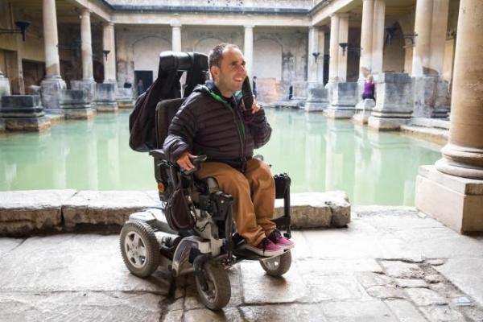

Welcome
The Roman Baths is one of the finest historic sites in Northern Europe, and one of the most popular tourist attractions in the UK.
At the heart of the City of Bath World Heritage Site, the Roman Baths consists of the remarkably preserved remains of one of the greatest religious spas of the ancient world. The city’s unique thermal springs rise in the site and the Baths still flow with natural hot water.
The Roman Baths and Pump Room with its elegant restaurant is located in Bath city centre next to Bath Abbey. There are numerous steps and uneven pavements, but lifts are available and 90% of the site is accessible to wheelchair users. We look forward to welcoming you.
Watch the video: Accessibility video for the Roman Baths & Pump Room

At a Glance

Level Access
- There is level access from the main entrance to:
  - Pump Room Restaurant
  - The Roman Baths Kitchen
  - Dining Table
  - Abbey Church Yard
  - Reception and ticket sales
  - Accessible toilet at the main entrance
  - Accessible toilet in the museum
  - The Roman Baths Shop (accessible from Stall Street)
  - Lower Museum Shop
  - Museum

Hearing
- The fire alarm has flashing lights.
- We have a hearing loop in ticket desks, shop, main meeting rooms.
- All staff have disability awareness training. Some staff have BSL training

Visual
- Some parts of the venue have low lighting.
- We have display information in audio, braille, BSL and large print.
- We have information in audio, braille, BSL and large print.

General
- We have a complimentary ticket policy for personal assistants.
- There is at least 1 public toilet for disabled visitors.
- All staff have disability awareness training.

Getting here
Stall Street
Bath
Somerset
BA1 1LZ

Travel by public transport
- You can get to The Roman Baths & Pump Room by bus and train.
- As the Roman Baths is in the centre of the city there are numerous bus stops nearby. The central bus station is next to the train station which is a ten minute walk away from the Roman Baths. The bus stop is 0.3 miles / 0.5 km from The Roman Baths & Pump Room.
- You can get a taxi with Abbey Taxis by calling 01225 444444. The taxi company has a wheelchair accessible vehicle.

Parking
- The nearest drop-off point is Terrace Walk, BA1 1LN. It is less than five minutes' walk to the Roman Baths. There are parking bays for Blue Badge holders in a number of locations in the city centre. Phone 01225 481744 or email shop_mobility@bathnes.gov.uk for the latest details. The nearest three hour parking spaces for Blue Badge holders are on Cheap Street, BA1 1NA.
- Watch the video: Accessible parking in Bath

Arrival

Path to main entrance
- From the street to the main entrance, there is level access.

Main entrance
- The main entrance has level access.
- The main door is side hung and manual.
- The door is 1320mm wide.
- Doors are open when the building is open to the public and there is always a security officer on the door to offer any assistance needed.
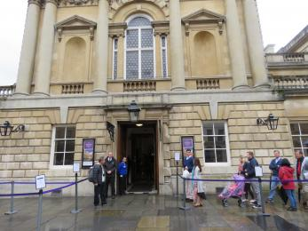
The Roman Baths main entrance

Getting around inside

Visual Impairment - General Information
- Some parts of the venue have low lighting.
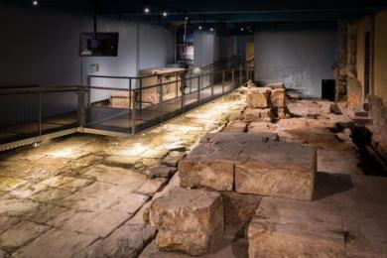
Temple Courtyard with walkway
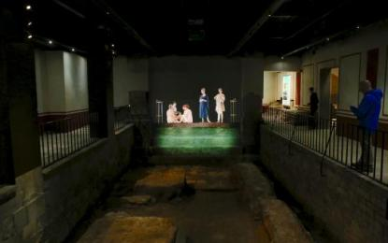
East Baths area with projections

Lift
- We have 4 lifts.
- You can get a lift to all floors.

Ticket/ information desk

Reception and ticket sales
- From the main entrance to the desk, there is level access. The desk has a low section.
- Each of the four till points has a lowered desk. Large print audioguide scripts, magnifying sheets or pens and paper are available for those with a hearing impairment. Braille signs and tactile models are placed throughout the museum.
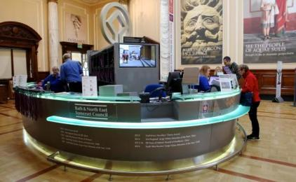
Ticket desk
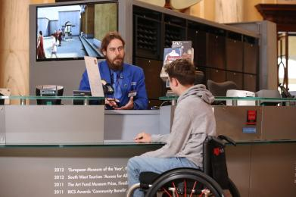
Visitor Experience Host at the ticket desk

Things to See and Do
- We have a complimentary ticket policy for personal assistants.
- We have performances with: audio-described and British Sign Language interpreted.
- We have display information in: audio, braille, BSL and large print.
- We have a designated quiet space.

Abbey Church Yard
- From the main entrance to this area, there is level access. Some display information is low, for wheelchair users. There are seats.
- The Abbey Church Yard is a large, open public space with entrances to the Roman Baths, Pump Room Restaurant and Roman Baths Kitchen.
There are benches opposite the main entrance.
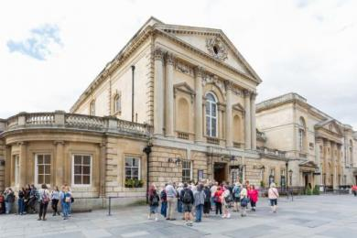
Abbey Church Yard with Roman Baths entrance
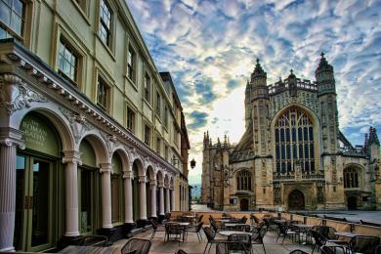
Exterior of the Roman Baths Kitchen restaurant

Public toilet

Accessible toilet at the main entrance
- There is a public toilet for disabled visitors.
- From the main entrance to the public toilet, there is level access. The toilet door is 890mm wide.
- The direction of transfer onto the toilet is to the left.
- There is 540mm at the side of the toilet. There is 1420mm in front of the toilet. The toilet seat is 480mm high. The toilets have handrails.
- Emergency pull cord and response provided. Support rails but limited transfer space on the left. There is a basin with mixer lever tap. There is a full size wheelchair WC in the museum which requires a radar key.
The nearest Changing Places toilet facility is at SouthGate Bath Shopping Centre, 12 Southgate Street, Bath BA1 1AQ.

Public toilet

Accessible toilet in the museum
- There is a public toilet for disabled visitors.
- You need a RADAR key to open the public toilet.
- From the main entrance to the public toilet, there is level access. There is a lift.
- From the lift to the public toilet, the route is 851mm wide, or more.
- The toilet door is 889mm wide.
- The direction of transfer onto the toilet is to the left.
- There is 1168mm at the side of the toilet. The toilet seat is 482mm high. The toilets have handrails.
- This unisex accessible toilet is at the West end of the Kings Bath corridor which is immediately after the Temple Precinct area. This toilet is accessed by a Radar key which is available from our staff. Emergency pull cord and response provided. There are support rails each side of the toilet and each side of the basin. There is a basin with mixer lever tap and a baby changing table.
The fire alarm includes a flashing light. The surface of the floor is non-slip laminate. There are baby changing facilities.
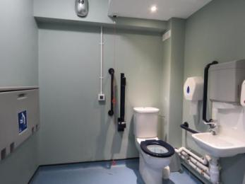
Baby changing facility on the left

Shop

The Roman Baths Shop (accessible from Stall Street)
- From the main entrance to the shop, there is level access. The route through the shop is 800mm wide, or more.
- Level access from the street through wide double doors. Steps up to the shop from the museum and down to the shop from the Pump Room. Wheelchair users can exit the Pump Room on to Abbey Church Yard and re-enter the shop from Stall Street (30 metres).
There is bright lighting on merchandise in the shop. All items are clearly priced and with low level displays. Staff are available to help if required. Low counter height for wheelchair users and hearing loop. There is also a smaller shop in the lower museum, accessible to wheelchair users. Both shops stock unique products to the Roman Baths.
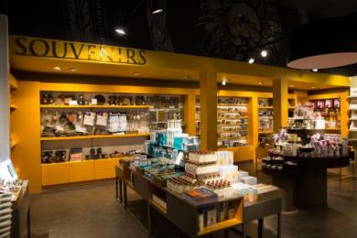
Inside the Roman Baths Shop
Staff are available to help

Shop

Lower Museum Shop
- From the main entrance to the shop, there is level access. There is a lift.
- The route through the shop is 800mm wide, or more.
- This is a small shop within the museum which is wheelchair accessible. A larger range of products is available in the main shop. Staff are available to help if required. Low counter height for wheelchair users and hearing loop.

Place to eat and drink

Pump Room Restaurant
- From the main entrance to the dining area, there is level access. To get to a table, there are no steps.
- The route through the dining area is 800mm wide, or more.
- There is background music.
- We cater for vegetarian, gluten free (celiacs) and vegan specific diets.
- Elegant restaurant in the historic Pump Room on the ground floor, with moveable seating and most tables with central support columns, giving good access for wheelchair users. Table service is provided and staff are always willing to give advice about menus and dietary needs and we can cater for most other diets by prior arrangement. Call 01225 444477 or email events.bath@searcys.co.uk.
There is live music every day performed by the Pump Room Trio or pianist.
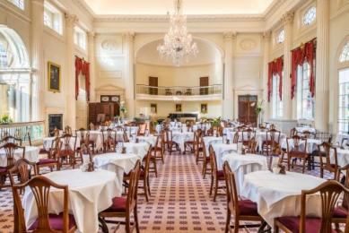
Inside the Pump Room Restaurant
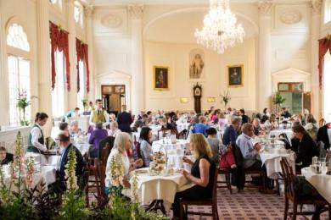
Visitors dining in the Pump Room Restaurant

Place to eat and drink

The Roman Baths Kitchen
- From the main entrance to the dining area, there is level access. To get to a table, there are no steps.
- There is background music.
- We cater for vegetarian, gluten free (celiacs) and vegan specific diets.
- A variety of platters and plates are used including wood and china. Staff are always willing to give advice about menus and dietary needs.
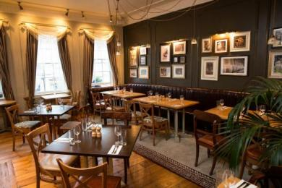
Inside the Roman Baths Kitchen
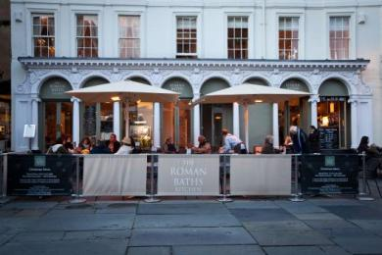
The Roman Baths Kitchen during the Christmas Market

Museum
- From the main entrance to this area, there is level access. There is a lift.
- The lift dimensions are total maximum weight 300kg and maximum length 1200mm
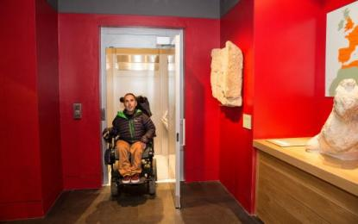
Exiting one of the lifts in the museum
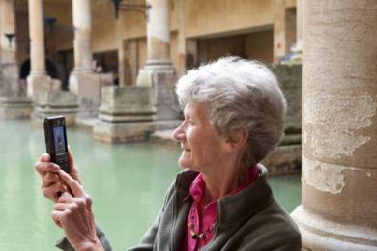
Using the BSL guide beside the Great Bath
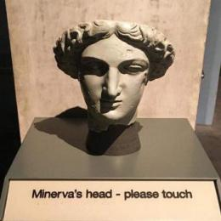
Tactile model of Minerva's head
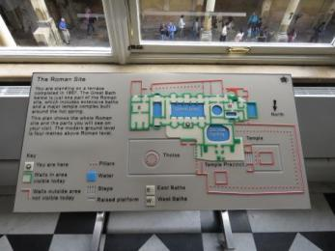
Tactile map of the Roman Baths
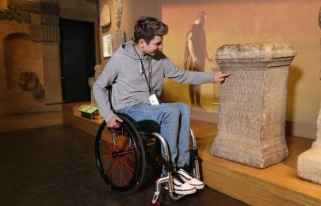
Interacting with the display

Customer care support

Accessibility equipment
- We provide wheelchairs. Wheelchairs are free.
- We have a hearing loop in ticket desks, shop, main meeting rooms.
- We have British Sign Language tours available on Opus Touch handsets available free of charge with your ticket. If you are a hearing aid user, we can provide you with an audioguide compatible with the "T" switch on hearing aids.These are issued beside our audioguides. We can also provide a printed copy of the audioguide text.
We have some Braille information panels and tactile models as well as a more descriptive audioguide for people with visual impairments, which describes things in greater detail. In addition we have magnifying sheets available.
We have tripod folding walking stick seats that can be borrowed.
A maximum of four wheelchair users can access the site at one time and we provide a plan of the site with a recommended route showing all the lifts and accessible toilets.
- For a list of more items, please go to https://www.romanbaths.co.uk/accessibility.
- You can hire mobility equipment from Shopmobility by calling 01225 481744.

Emergency evacuation procedures
- We have emergency evacuation procedures for disabled visitors.
- The fire alarm has flashing lights.
- Details of evacuation and safe refuge points are listed on the wheelchair users plan of the site. This plan can be downloaded from the accessibility page on our website.

Customer care support
- All staff have disability awareness training.
- Some staff have BSL training.
- We have information in audio, braille, BSL and large print.
- We offer audioguides in 12 languages as well as BSL. We also offer a children's audioguide in English, French and German.
- We have other services for people with accessibility requirements.
- We are an Autism Friendly attraction aiming to help give a smooth visit with no unexpected surprises. We provide an information sheet for visitors with autism and an easy read version which can be downloaded from our website, to help plan a successful visit https://www.romanbaths.co.uk/accessibility
Members of staff have the opportunity to attend Dementia Friends information sessions and we are part of the local Dementia Action Alliance.
Please let staff know of any extra help you need or you can phone 01225 477785 before your visit.

Guide last updated: 18 January 2019

